Project Design Phase-II Data Flow Diagram &User Stories

|  |  |
| --- | --- |
| Date | 12 October 2022 |
| Team ID | PNT2022TMID43983 |
| Project Name | Plasma Donor Application |
| Maximum Marks | 4 Marks |

# Data Flow Diagram:

A data-flow diagram is a way of representing a flow of data through a process or a system. The DFD also provides information about the outputs and inputs of each entity and the process itself. A data-flow diagram has no control flow — there are no decision rules and no loops.

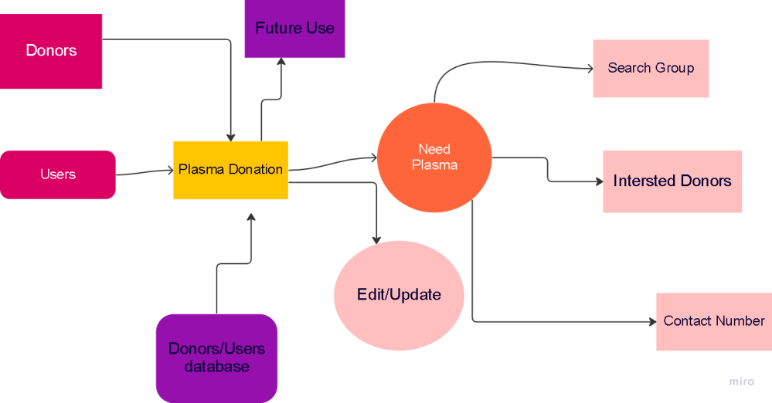

# User Stories:

|  |  |  |  |  |  |  |
| --- | --- | --- | --- | --- | --- | --- |
| **User Type** | **Functional**  **Requirement (Epic)** | **User Story Number** | **User Story / Task** | **Acceptance criteria** | **Priority** | **Release** |
| Customer (Mobile user) | Registration | USN-1 | User can register for this application by entering their email id, password, and confirming their password. | User can access their account / dashboard | High | Sprint-1 |
|  | Confirmation | USN-2 | User will receive confirmation email once they have registered for the application | User will receive the confirmation mail in the registered mail id & click  confirm | High | Sprint-1 |
|  | Access application | USN-3 | User can register for the application through application website | User can register & access the application in  their available devices | Low | Sprint-2 |
|  | Registration Gmail | USN-4 | User can register for the application through Gmail | User can receive successful registration Gmail | Medium | Sprint-1 |
|  | Login | USN-5 | User can login through the application by email and password | User can enter into application successfully by applying valid email and  password | High | Sprint-1 |
| Customer (Web user) | Access Website | USN-6 | Capable to access web application through an browser | User can access web- application | Medium | Sprint-1 |
|  | Search for donor | USN-7 | Search result can be viewed in a list | User can view list  represents a specific donor with donor details | High | Sprint-1 |
| Customer Care Executive | Software Operator | USN-8 | User should be able to register through application. Donor must provide username, gender, blood group, location, contact. | The user’s response surprised us positively | High | Sprint-1 |
|  | View request | USN-9 | The customer care executive should be able to view received request and then respond to them | User can receive the request response immediately | High | Sprint-1 |
| Administrator | Maintenance | USN-10 | Admin can access, view, modify, update all details of the plasma donor application | Admin is the authorized person of the overall application. | High | Sprint-1 |